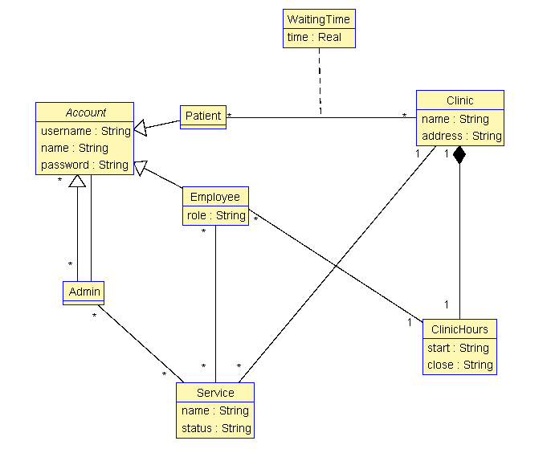

**Contributions**

|  |  |  |  |  |
| --- | --- | --- | --- | --- |
| **Name** | **Deliverable 1** | **Deliverable 2** | **Deliverable 3** | **Deliverable 4** |
| Roman Koval |  |  |  |  |
| Noel Khalaf |  |  |  |  |
| Rylan Deck |  |  |  |  |
| John Adkin |  |  |  |  |
| Aman Brar | Class diagram for UML domain model | Class diagram for UML domain model | Class diagram for UML domain model | Class diagram for UML domain model and report |

**Lessons Learned and Suggestions**